www.htlcmpls.org/faithfulenergy
Below I have included some sample Images that could be included in our letter, email and web site

Faithful Energy
Holy Trinity Lutheran Church is beginning a new project to use the gifts of creation more responsibly. We are launching a project – Faithful Energy - to increase the use of renewable energy for our church building and in the homes of congregation members.
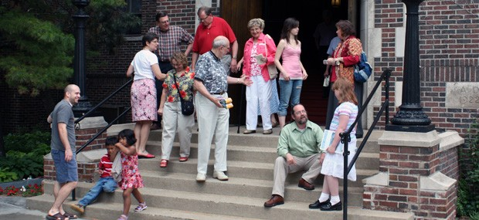
FIRST - We are starting by signing up members for wind power through Windsource
Starting on the Sunday after Easter, April 12 through Pentecost Sunday, May 24 through our Faithful Energy Campaign a volunteer team will help families in our congregation to sign up for the Windsource Program of Xcel Energy. Windsource is a voluntary program for residential and business customers to purchase (for a small monthly fee added to their electric bill) electricity generated by renewable sources such as wind power. Individuals can commit to purchasing different amounts of energy through Windsource, up to 100% of their total electricity bill. Our church building will be entirely subscribed to Windsource beginning in April! A 100% subscription for an averaged sized house increases the electric bill by about $4 a month.
What - Our Goal – to sign up 80% of Holy Trinity member households for Windsource by May 24.
Why – As a community of faith – to use the gifts of creation responsibly.
How – Signing up for Windsource
- Sign up for Windsource by calling 1-800-895-4999 or visit www.xcelenergy.com/Windsource

- Tell us that you have subscribed for Windsource (earlier or now) so we can count you toward our total – with our quick survey. http://tinyurl.com/HolyTrinityFaithfulEnergy

- If you live in another utility service area find your renewable power option here
http://www.pca.state.mn.us/index.php/living-green/living-green-citizen/buying-green/buy-green-power.html

- Windsource Fact Sheet www.xcelenergy.com/staticfiles/xe/Marketing/Files/Windsource-Minnesota-Res-FAQs.pdf


Once we reach our Faithful Energy Windsource goal, we’ll look ahead to

We are working to add solar panels to our roof top at Holy Trinity
Holy Trinity’s Property Committee is working with a solar company in our neighborhood to install a 40kw solar system on our congregation’s roof. This will provide about 25% of our congregation’s electricity. We will look for meeting the rest of our building’s electricity needs through subscribing to community solar garden.
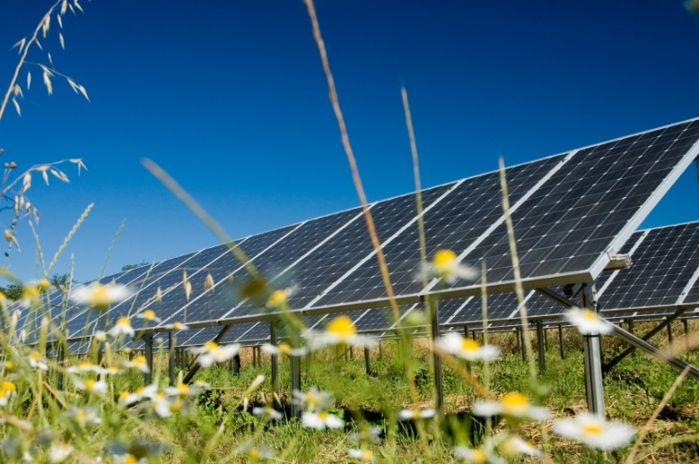
We will be inviting our members to buy renewable electricity from a community solar garden.
We will then share with our members one or more options to buy affordable renewable electricity through a sustainably developed community solar garden.
We are encouraging our members to take additional steps to save energy & money.
We will continue to explore options for our members to save energy and money for example by participating in the enhanced home energy squad program in our neighborhood with the Center for Energy and Environment
http://mncee.org/What-We-Do/Program-Design-and-Delivery/Home-Energy-Squad-Enhanced/
We are supporting wise public policies to help Minnesota achieve it’s Co2 reduction goals to protect our climate while strengthening our economy.
MN Clean Energy and Jobs Campaign – supporting Minnesota to increase our energy efficiency standard from 1.5% to 2% and our renewable electricity standard from 25% to 40% www.cleanenergyjobs.mn

Move MN Coalition – supporting sustainable funding for transit, bike trails and road maintenance www.movemn.org

