Ninth Sunday
after Pentecost

August 10, 2014

Holy Trinity Lutheran Church

Minneapolis
Welcome to All

The people of Holy Trinity Lutheran Church wish to extend a special welcome to all visitors.
Please leave your name and phone number on the visitor card found in the pew.

We are committed to the inclusion of all people, with no exception.
Therefore we practice open communion, welcoming all to the table
to receive the sacrament of Holy Communion.

Child care is available in the nursery for infants through age 6.

If you are seeking pastoral care, please speak to a pastor today.

Prelude Aria from Suite Modale Flor Peeters

Gather

Gathering Hymn Oh, Sing to the Lord Red Hymnal 822

Greeting

The grace of our Lord Jesus Christ, the love of God, and the communion of the Holy Spirit be with you all. And also with you.

Hymn of Praise
Cantor
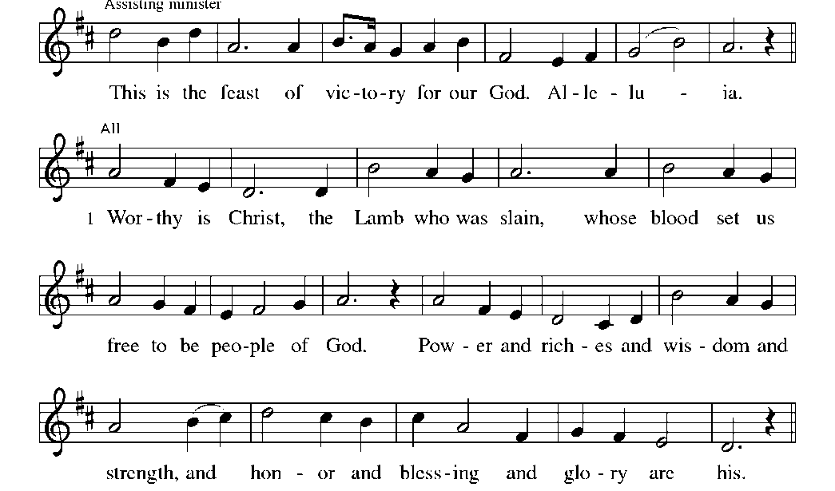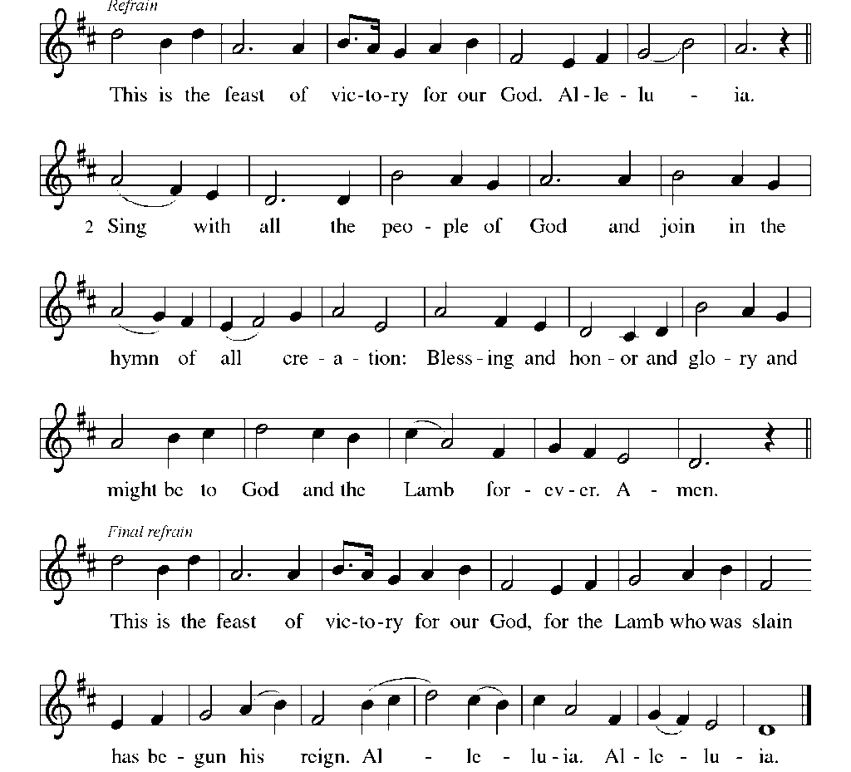
All

Prayer of the Day

Through the storms of life, O God, you are with your people in the person of Jesus your Son.
Calm our fears and strengthen our faith that we may never doubt his presence among us but proclaim that he is your Son, risen from the dead, living for ever and ever. Amen.

Word

First Reading Genesis 37:1-4, 12-28 Old Testament, Pages 34-35

Word of God; word of life. Thanks be to God.

Psalm 105 Michael Morgan

(Cantor) 1. Praise the Lord, the day is won! Glory, hallelujah!
God for us great things has done. Sing, shout hallelujah!
Now let all the earth proclaim resurrection wonder;
In God’s all enduring name, death is cast asunder!

All 2. Loosed from chains by bondage cast; glory, hallelujah!
God has freed our souls at last. Sing, shout hallelujah!
Slaves held captive for so long, scarred by sin and sadness,
Lift anew their victory song, filled with joy and gladness!

(Cantor) 3. As God’s spirit moved the sea; glory, hallelujah!
Set our hearts at liberty. Sing, shout hallelujah!
In our darkest, dreadful day, crushed by grief and mourning;
God will roll the stone away, radiant love adorning.

All 4. God’s great covenant is sealed! Glory, hallelujah!
Our salvation is revealed. Sing, shout hallelujah!
Plagues no more confound the flock, flames nor flood assail us;
Sure as water from the rock, God will never fail us!

5. Faithful in the Lord rejoice. Glory, hallelujah!
Raise to God our new-found voice. Sing, shout hallelujah!
Crowned with full redemption’s light, by God’s grace befriended;
Life, behold the glorious sight; death, your reign is ended!

Second Reading Romans 10:5-15 New Testament, Page 152

Word of God; word of life. Thanks be to God.

Gospel Acclamation Alleluia! Red Hymnal, liturgy page 151

Gospel Reading Matthew 14:22-33 New Testament, Page 15

Word of God; word of life. Thanks be to God.

Sermon

Hymn of the Day The Risen Christ Red Hymnal 390

Intercessions

With the whole people of God in Christ Jesus, let us pray for the church, those in need, and all of God’s creation.

(silence)

Into the tender cracks of our lives, your mercy flows. Our troubled relationships and our grief, our fear and our chronic pain, our dying and our living—nothing is hidden from your gentleness. We give you thanks that in your knowing there is grace. Compassionate God,
Hear our prayer.

Maker of the skies above and the flowing waters, we trust that you go with the members of this congregation paddling through the Boundary Waters. Forgive us when we trample your creation; inspire us to step lightly and attentively. Compassionate God,
Hear our prayer.

We praise you for sweet community—for ancestors and those still to come, for the nameless and the well-known, for heretics and workers and slackers, for poets and farmers and teachers, for children and elders, for strangers and best friends. Compassionate God,
Hear our prayer.

As your disciples pleaded for salvation on the stormy sea, so too do we ask you to come to the help of our sisters and brothers in Liberia, Guinea, Sierra Leone, and elsewhere affected by Ebola. Send your Holy Spirit to love those in quarantine, to give strength to health workers and volunteers, and to comfort those families whose lives have been forever changed by this virus. Compassionate God,
Hear our prayer.

You are invited to offer spoken petitions. Please close your petition with,
“Compassionate God,” to which the congregation will respond, “hear our prayer.”

Into your hands, gracious God, we commend all for which we pray, trusting in your mercy; through Jesus Christ, our Savior. Amen.

Meal

Peace

The peace of Christ be with you always.
And also with you.

You are invited to exchange words and signs of fellowship and love with those around you.

Offering

Offertory Hymn Let the Vineyards Red Hymnal 184

Offering Prayer

God of mercy and grace, the eyes of all wait upon you, and you open your hand in blessing. Fill us with good things at your table, that we may come to the help of all in need. Amen.

Great Thanksgiving

The Lord be with you
And also with you.

Lift up your hearts.
We lift them to the Lord.

Let us give thanks to the Lord our God.
It is right to give our thanks and praise.

It is indeed right, our duty and our joy, that we should at all times and in all places give thanks and praise to you, O God, through Christ our Lord; who on this day overcame death and the grave, and by his glorious resurrection opened to us the way of everlasting life.
And so, with the church on earth and the hosts of heaven, we praise your name and join their unending hymn:

Sanctus

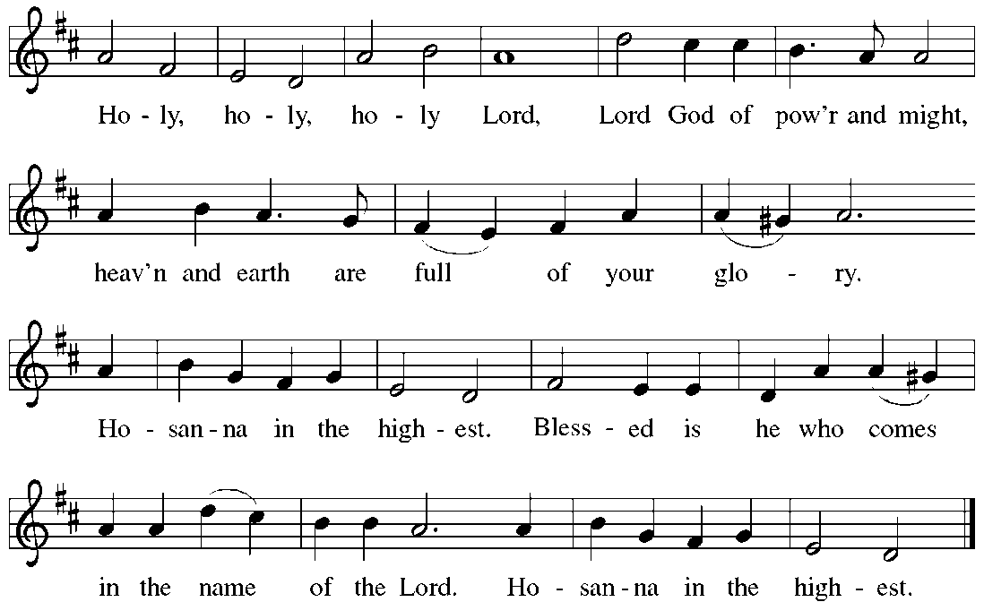

Words of Institution

Lord’s Prayer

Living in trust and hope, we pray as Jesus taught us:

Our Father in heaven, hallowed be your name,
your kingdom come, your will be done, on earth as in heaven.
Give us today our daily bread.
Forgive us our sins as we forgive those who sin against us.
Save us from the time of trial and deliver us from evil.
For the kingdom, the power, and the glory are yours, now and forever. Amen.

Lamb of God
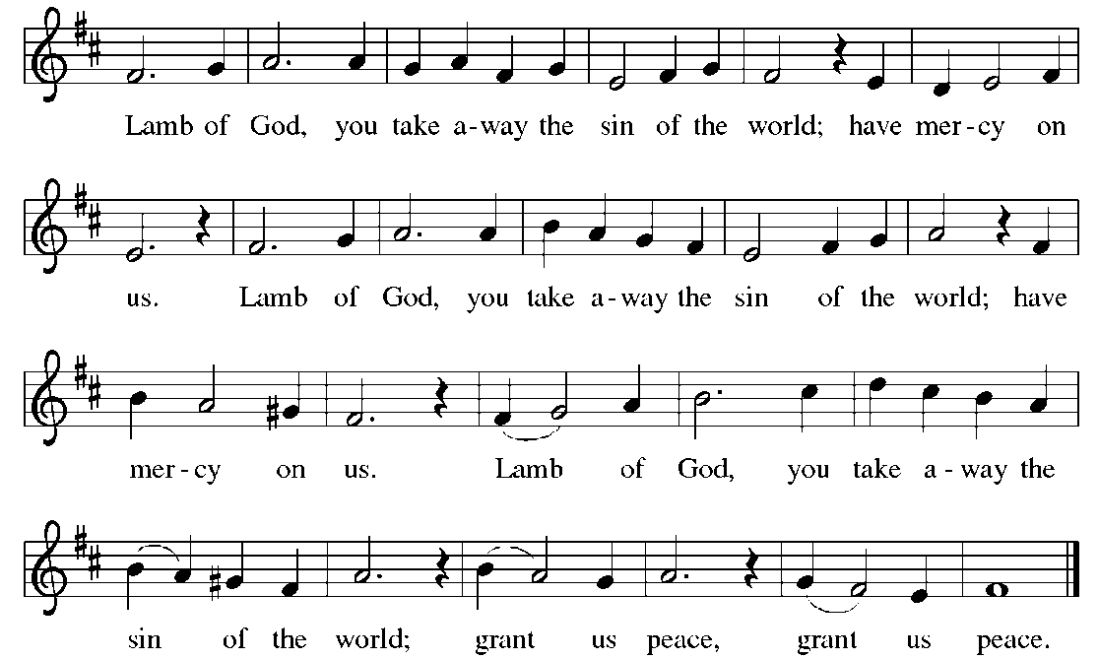

All are welcome at the table.
Grape juice and gluten-free wafers are available upon request to the server.

An usher will direct you down the center aisle, where an acolyte will offer you a communion cup. You are invited to stand or kneel in front of the table, beginning from the outside and moving toward the middle. After you have received the bread and the wine, please return to your seat by way of the side aisle, where an usher will receive your communion cup.

Distribution Hymn When Peace like a River Red Hymnal 785

Distribution Hymn Calm to the Waves Red Hymnal 794

Blessing

The body and blood of Jesus Christ strengthen you and keep you in God’s grace. Amen.

Post Communion Prayer

We thank you, mighty and compassionate God, that you have fed us through this sacrament in a way our hearts can understand. Enliven us by your presence in this meal, that we may be your presence in the world, through Jesus the Christ.
Amen.

SENDING

Sending Hymn My Life Flows On in Endless Song Red Hymnal 763

Benediction

The God of steadfastness and encouragement grant you to live in harmony with one another. The God of hope fill you with all joy and peace in believing. The God of all grace bless you now and forever.
Amen.

Dismissal

Go in peace. Christ is with you.
Thanks be to God.

Postlude Festival Voluntary Flor Peeters

You are invited to the Community Room
(located at the rear of the worship area) for a time of fellowship and refreshments.
Holy Trinity Lutheran Church
2730 East 31st Street, Minneapolis, MN 55406
612-729-8358 htlcmpls.org

LITURGY: ELW Setting Four

Worship Participants

8:45 AM |  | 11:00 AM
Jay Carlson | Preacher | Jay Carlson
Joel Wiberg | Presiding Minister
Josh Becker | Crucifer | Jeff Weiss
Paul Thorson | Cantor | Paul Thorson
 | Acolytes | Sara Christians, Mason Helmel
Karen Batdorf | Assisting Minister | Lynda Nordholm
Bruce Martens, Joyce Peterson | Communion | Sue Roberts, Susan Wootten
Bob/Bev Peschiutta, Chris Engen | Ushers | George Madich, Mark Hiner, Bob/Helen Norheim
Gerry/Linda Berglin | Altar Guild | Joe Fortier, Linda Woytasek
Gina Gainous, PH Copeland | Nursery | Gina Gainous, PH Copeland
Chris/Mary Engen | Coffee Servers | Sean Gosiewski/Rachel Hefte
Ron/Margaret Peterson | Counters | Gary Johnson, Mary Ellen Olson
 | Closer | Deb Sodt
Copyright permission is granted under annual copyright license A-704054 with OneLicense, Chicago IL.

Staff
Jay Carlson, Pastor
Ingrid Rasmussen, Pastor
Stephanie Sulzbach, Church School
Meghan Olsen Biebighauser,
Parish Organizing Leader
Vicki Mann, Church Administrator
Nolan Gusdal, Building Maintenance
Kathy Ekwall, Custodian

Leadership
Jeff Olsen Biebighauser, Council President
Sara Jensen, Council Vice President
Laura Bolstad, Council Secretary
Gerry Berglin, Treasurer

Music
Timothy Buendorf, Organist
Ann Schrooten, Children’s & Youth Music
Rachel Trelstad Porter, Accompanist
Stephanie Oyen, Accompanist
Kelsey Porter, Accompanist

P A R I S H I N F O R M A T I O N

MUSIC IN THE GARDEN
Join us from 12:00-1:00 in the Rain Garden for fellowship and music from Lake Street Bridge. Lake Street Bridge is Bob Aldrich and Paul Baglyos, two musicians living on opposite sides of the Mississippi. Two guitars, all original instrumentals, an amalgam of blues, jazz, and American fingerstyle.

MEALS ON WHEELS
Holy trinity will be delivering meals for South Minneapolis Meals on Wheels the week of August 18-22. Volunteers are needed to pick up and deliver meals during these days. Meals are picked up at 11:10 a.m. at Nokomis Square delivery area, 35th Ave. and 50th St. Delivery takes about 1 hour. You may volunteer for 1-5 days. A sign-up list is in the Community Room, or you may call Mary Engen at 612-721-7181.

updated fall retreat information
Please plan to join us October 10-11 (please note the date correction) for the Holy Trinity Fall Retreat to Villa Maria in Frontenac, MN, located about 90 minutes southeast of the Twin Cities. You've heard a lot about multi-tasking; come and learn more about mono-tasking. We'll spend time with spiritual practices like guided meditation and centering prayer. We'll move our bodies as we learn simple yoga motions, walk the labyrinth, and spend time in nature. We'll try our hand at journaling about life and faith. Cost: approximately $100, food and lodging included. Indicate your interest in the Community Room. Questions? Talk to Liz Blood, Lisa Martens, or Pastor Ingrid.

WRITERS’ CIRCLE
All are welcome to join the Holy Trinity Writers’ Circle. On the second Tuesday of every month, a small group of writers meet to give one another support in their craft. Join them at their next meeting, August 12, from 6:30-8:00 p.m. in the Mary Martha Room.

Longfellow corn Feed
The 44th Annual Longfellow Corn Feed will be Thursday, August 14, at Longfellow Park (3435 36th Ave. S.). This year will have all the staples of the Corn Feed: live music, a resource fair featuring local businesses and organizations, ice cream, games, activities, and (of course!) roasted corn. A lovely summer evening with plenty of activities. Keep your eyes open for the Holy Trinity table!

HOLY TRINITY CAMPING TRIP
Plans are being made for an intergenerational camping weekend, September 19-21. Please mark your calendars. It will take place at Nerstrand Big Woods group camp. All are welcome! Talk to Pastor Jay or Theresa Rian for more information about this event. A sign-up sheet is available in the Community Room.

Listening for Stories of Creation
Members of the Peace with Justice committee and Holy Trinity's Creation Care team are embarking on a month of creation conversations, listening for places and issues that are close to the hearts of Holy Trinity members. Want to participate or have a story to share? Contact Meghan at the church office or molsen@htlcmpls.org.

RACE: THE POWER OF AN ILLUSION
The Outreach Committee invites all to view the second session of Race: The Power of an Illusion and to engage in conversation about race, difference, faith, and justice, Tuesday, August 12, from 7-9 p.m. in the library. Please join us, even if you were unable to attend the first session. We’d like your voice and your experiences represented at the conversation table.

JAVEN SWANSON ORDAINED AT GLORIA DEI TODAY
Javen Swanson, former Holy Trinity intern, will be ordained at Gloria Dei Lutheran Church today at 3:00 p.m. All are welcome. The church is located at 700 South Snelling, St. Paul, MN. A reception will follow.
P A R I S H S C H E D U L E

Monday, August 11 | 7:00 PM | Christian Ed. meeting
Tuesday, August 12 | 6:30 PM  7:00 PM | Writers’ Circle  Viewing of Race: The Power of an Illusion, Part II
Thursday, August 14 | 8:30 AM-5 PM  5:30 – 8:00 PM | LVC Orientation  Longfellow Corn Feed at Longfellow Park
Friday, August 15 | 1:00 PM | Youth bike ride, pool, and pizza party at Benson’s
Sunday, August 17 | 8:45 AM  10:00 AM  11:00 AM  2:00 PM | Worship Service of Holy Communion  Adult Forum  Worship Service of Holy Communion  Swahili Service

Adult Forum
10:00 a.m. each Sunday in the Library

TODAY “Children in Worship”
Pastor Jay Carlson
Among the list of five promises parents make to their infants during the service of baptism is to “bring them to the word of God and the holy supper.” It sounds simple at the time, but some parents later find bringing their kids to church to be among the hardest things they do during the week. Why is it important? How can our congregation live out the promise we make at baptisms to support children and their parents? All are invited to participate in this discussion about children and worship.

August 28 “Godly Play”
Kay Buzza
Children have an innate sense of the presence of God. The Godly Play approach helps them to explore their faith through story, to gain religious language, and to enhance their spiritual experience through wonder and play. Kay Buzza, with the help of Stephanie Sulzbach and others, led a wonderful first year of Godly Play for our youngest Sunday School students last year. Come join Kay and her students to experience Godly Play for yourselves. We will meet in the Godly Play classroom on the third floor.

